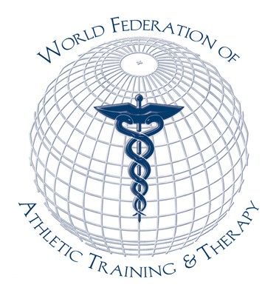
World Federation of Athletic Training and Therapy

Academic Institution Employment Board

As a benefit of membership with the World Federation of Athletic Training and Therapy (WFATT), academic institutions are afforded the oppportnity to post call for applications for academic employment positions free of charge on the WFATT website. The following terms of posting will apply:

- Only WFATT academic institution members are eligible to post to the Employment Board
- Postings are limited only to faculty positions at the member institution.
- Postings will be posted for a maximum of 30 days or until the position is filled whichever comes first.
- The information must be provided in pdf format.
- All further communication related to the employment opportunity would be directed to the academic institution.
- The WFATT assumes no responsibility for the information or lack of information posted by the institution.

Application Form

Institution
Contact Name
Contact Position
Contact information (email)
Academic Position(s)
Application Deadline

Please submit a single pdf document outlining the call for applications and the terms of employment to Glen Bergeron (g.bergeron@uwinnipeg.ca).

